

Technical Safety Concept Lane Assistance

**Document Version:** 2.0

**Template Version 1.0, Released on 2017-06-21**



# Document history

|  |  |  |  |
| --- | --- | --- | --- |
| Date | Version | Editor | Description |
| 24-05-2018 | 1.0 | Sharath Srinivasan | Initial Draft |
| 25-05-2018 | 2.0 | Sharath Srinivasan | LKA Safe State Modification |
|  |  |  |  |
|  |  |  |  |
|  |  |  |  |

# 

# Table of Contents

Document history

Table of Contents

Purpose of the Technical Safety Concept

Inputs to the Technical Safety Concept

Functional Safety Requirements

Refined System Architecture from Functional Safety Concept

Functional overview of architecture elements

Technical Safety Concept

Technical Safety Requirements

Refinement of the System Architecture

Allocation of Technical Safety Requirements to Architecture Elements

Warning and Degradation Concept

# Purpose of the Technical Safety Concept

The Technical Safety Concept defines how the subsystems interact at the message level and describes how the ECUs communicate with each other.

# Inputs to the Technical Safety Concept

## Functional Safety Requirements

|  |  |  |  |  |
| --- | --- | --- | --- | --- |
| **ID** | **Functional Safety Requirement** | **ASIL** | **Fault Tolerant Time Interval** | **Safe State** |
| Functional  Safety  Requirement  01-01 | The lane keeping item shall ensure that the lane departure warning oscillating torque amplitude is below Max_Torque_Amplitude | C | 50 ms | The system will be in Off state as the LDW will set the oscillating torque amplitude to 0. |
| Functional  Safety  Requirement  01-02 | The lane keeping item shall ensure that the lane departure warning oscillating torque amplitude is below Max_Torque_Frequency | C | 50 ms | The system will be in Off state as the LDW will set the oscillating torque amplitude to 0. |
| Functional  Safety  Requirement  02-01 | The electronic power steering ECU shall ensure that the lane keeping assistance torque is applied for only Max_Duration | B | 500 ms | The system will be in Off state as the LKA will set the oscillating torque amplitude to 0. |

## Refined System Architecture from Functional Safety Concept

### Functional overview of architecture elements

|  |  |
| --- | --- |
| **Element** | **Description** |
| Camera Sensor | This system captures images of the road surface and sends the images to the Camera Sensor ECU. |
| Camera Sensor ECU - Lane Sensing | This system receives input from the Camera Sensor. Identifies when the vehicle has accidentally departed the ego lane and transmits the appropriate signal to the Torque request generator of the Camera Sensor ECU. |
| Camera Sensor ECU - Torque request generator | This system operates when the Lane Sensing block of the Camera Sensor ECU detects a lane departure, the torque request generator sends a signal to the Electronic Power Steering ECU to apply steering torque to correct the position. |
| Car Display | This system Displays warnings generated by the Car Display ECU to the driver about the status of various subsystems. |
| Car Display ECU - Lane Assistance On/Off Status | This system displays the on/off status of the Lane Assistance system. |
| Car Display ECU - Lane Assistant Active/Inactive | This system displays the active or inactive status of the Lane Assistance system. |
| Car Display ECU - Lane Assistance malfunction warning | This system Turns on when the Lane Assistance system malfunctions. |
| Driver Steering Torque Sensor | This system Senses the amplitude and frequency of steering torque and sends the information to the Electronic Power Steering ECU. |
| Electronic Power Steering (EPS) ECU - Driver Steering Torque | Determines the current amount of torque applied in the steering system. |
| EPS ECU - Normal Lane Assistance Functionality | This system receives torque requests from the Camera Sensor ECU and passes relevant torque requests to the LDW and LKA blocks. |
| EPS ECU - Lane Departure Warning Safety Functionality | This system activates when there is a Primary_LDW_Torque_Request, generating a torque request to the Final Torque block. |
| EPS ECU - Lane Keeping Assistant Safety Functionality | Activates when there is a Primary_LKA_Torque_Request, generating a torque request to the Final Torque block. |
| EPS ECU - Final Torque | Combines torque requests from the LDW Safety block and LKA safety block with the driver steering torque to a final output torque. |
| Motor | Applies the steering torque defined by the Final Torque block. |

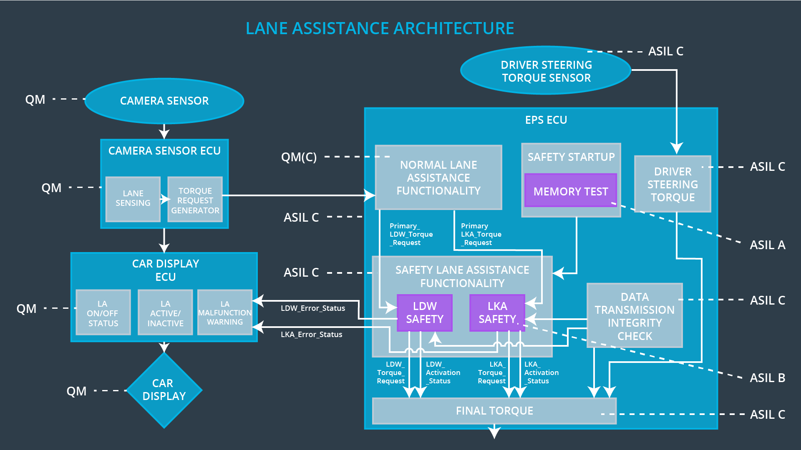

Figure 1: System Architecture Diagram

# Technical Safety Concept

## Technical Safety Requirements

**Lane Departure Warning (LDW) Requirements:**

Functional Safety Requirement 01-01 with its associated system elements

(derived in the functional safety concept)

|  |  |  |  |  |
| --- | --- | --- | --- | --- |
| **ID** | **Functional Safety Requirement** | **Electronic Power Steering ECU** | **Camera ECU** | **Car Display ECU** |
| Functional  Safety  Requirement  01-01 | The lane keeping item shall ensure that the lane departure oscillating torque amplitude is below Max_Torque_Amplitude | X |  |  |

Technical Safety Requirements related to Functional Safety Requirement 01-01 are:

|  |  |  |  |  |  |
| --- | --- | --- | --- | --- | --- |
| **ID** | **Technical Safety Requirement** | **ASIL** | **Fault Tolerant Time Interval** | **Architecture Allocation** | **Safe State** |
| Technical  Safety  Requirement  01 | The LDW safety component shall ensure that the amplitude of the ‘LDW_Torque_Request’ sent to the ‘Final electronic power steering Torque’ component is below ‘Max_Torque_Amplitude’ | C | 50 ms | LDW Safety | The LDW system would have the Torque Request Amplitude set to zero |
| Technical  Safety  Requirement  02 | The validity and integrity of the data transmission for ‘LDW_Torque_Request’ signal shall be ensured | C | 50 ms | Data Transmission Integrity Check | The LDW system would have the Torque Request Amplitude set to zero |
| Technical  Safety  Requirement  03 | As soon as a failure is detected by the LDW function, it shall deactivate the LDW feature and the ‘LDW_Torque_Request’ shall be set to zero | C | 50 ms | LDW Safety | LDW Torque Request Amplitude shall be set to zero |
| Technical  Safety  Requirement  04 | As soon as the LDW function deactivates the LDW feature, the ‘LDW Safety’ software block shall send a signal to the car display ECU to turn on a warning light | C | 50 ms | LDW Safety | LDW Torque Request Amplitude shall be set to zero |
| Technical  Safety  Requirement  05 | Memory test shall be conducted at start up of the EPS ECU to check for any faults in memory. | A | Length of vehicle ignition cycle | Memory Test | LDW Torque Request Amplitude shall be set to zero |

Functional Safety Requirement 01-2 with its associated system elements

(derived in the functional safety concept)

|  |  |  |  |  |
| --- | --- | --- | --- | --- |
| **ID** | **Functional Safety Requirement** | **Electronic Power Steering ECU** | **Camera ECU** | **Car Display ECU** |
| Functional  Safety  Requirement  01-02 | The lane keeping item shall ensure that the lane departure oscillating torque frequency is below Max_Torque_Frequency | X |  |  |

Technical Safety Requirements related to Functional Safety Requirement 01-02 are:

|  |  |  |  |  |  |
| --- | --- | --- | --- | --- | --- |
| **ID** | **Technical Safety Requirement** | **ASIL** | **Fault Tolerant Time Interval** | **Architecture Allocation** | **Safe State** |
| Technical  Safety  Requirement  01 | The LDW safety component shall ensure that the frequency of the ‘LDW_Torque_Request’ sent to the ‘Final electronic power steering Torque’ component is below ‘Max_Torque_Frequency’ | C | 50 ms | LDW Safety | LDW Torque Request Frequency should be set to zero |
| Technical  Safety  Requirement  02 | The validity and integrity of the data transmission for ‘LDW_Torque_Request’ signal shall be ensured | C | 50 ms | Data Transmission Integrity Check | LDW Torque Request Frequency should be set to zero |
| Technical  Safety  Requirement  03 | As soon as a failure is detected by the LDW function, it shall deactivate the LDW feature and the ‘LDW_Torque_Request’ shall be set to zero | C | 50 ms | LDW Safety | LDW Torque Request Frequency should be set to zero |
| Technical  Safety  Requirement  04 | As soon as the LDW function deactivates the LDW feature, the ‘LDW Safety’ software block shall send a signal to the car display ECU to turn on a warning light | C | 50 ms | LDW Safety | LDW Torque Request Frequency should be set to zero |
| Technical  Safety  Requirement  05 | Memory test shall be conducted at start up of the EPS ECU to check for any faults in memory. | A | Length of vehicle ignition cycle | Memory Test | LDW Torque Request Frequency should be set to zero |

**Lane Keeping Assistance (LKA) Requirements:**

Functional Safety Requirement 02-1 with its associated system elements

(derived in the functional safety concept)

|  |  |  |  |  |
| --- | --- | --- | --- | --- |
| **ID** | **Functional Safety Requirement** | **Electronic Power Steering ECU** | **Camera ECU** | **Car Display ECU** |
| Functional  Safety  Requirement  02-01 | The lane keeping item shall ensure that the lane keeping assistance torque is applied for only Max_Duration | X |  |  |

Technical Safety Requirements related to Functional Safety Requirement 02-01 are:

|  |  |  |  |  |  |
| --- | --- | --- | --- | --- | --- |
| **ID** | **Technical Safety Requirement** | **ASIL** | **Fault Tolerant Time Interval** | **Allocation to Architecture** | **Safe State** |
| Technical  Safety  Requirement  01 | The LKA safety component shall ensure that the amplitude of the ‘LKA_Torque_Request’ sent to the ‘Final electronic power steering Torque’ component is set to zero once ‘Max_Duration’ has been exceeded | B | 500 ms | LKA Safety | LKA Torque Request Amplitude should be set to zero. |
| Technical  Safety  Requirement  02 | The validity and integrity of the data transmission for ‘LKA_Torque_Request’ signal shall be ensured | B | 500 ms | Data Transmission Integrity Check | LKA Torque Request Amplitude should be set to zero. |
| Technical  Safety  Requirement  03 | As soon as a failure is detected by the LKA function, it shall deactivate the LKA feature and the ‘LKA_Torque_Request’ shall be set to zero | B | 500 ms | LKA Safety | LKA Torque Request Amplitude has to be set to zero. |
| Technical  Safety  Requirement  04 | As soon as the LKA function deactivates the LKA feature, the ‘LKA Safety’ software block shall send a signal to the car display ECU to turn on a warning light | B | 500 ms | LKA Safety | LKA Torque Request Amplitude should be set to zero. |
| Technical  Safety  Requirement  05 | Memory test shall be conducted at start up of the EPS ECU to check for any faults in memory. | A | Length of vehicle ignition cycle | Memory Test | LKA Torque Request Amplitude has be set to zero. |

## Refinement of the System Architecture



Figure 2: System Architecture Diagram

## Allocation of Technical Safety Requirements to Architecture Elements

For the item outlined in this document, all technical safety requirements are allocated to the Electronic Power Steering ECU.

## Warning and Degradation Concept

|  |  |  |  |  |
| --- | --- | --- | --- | --- |
| **ID** | **Degradation Mode** | **Trigger for Degradation Mode** | **Safe State invoked?** | **Driver Warning** |
| WDC-01 | Steering torque frequency and/or amplitude are degraded. | Steering torque exceeds Max_Torque_Frequency and/or Max_Torque_Amplitude | Yes | The system should turn on the warning light on dashboard. |
| WDC-02 | Lane keeping assistance function will turn off. | Torque is applied for a duration exceeding Max_Duration | Yes | The system should turn on the warning light on dashboard |